 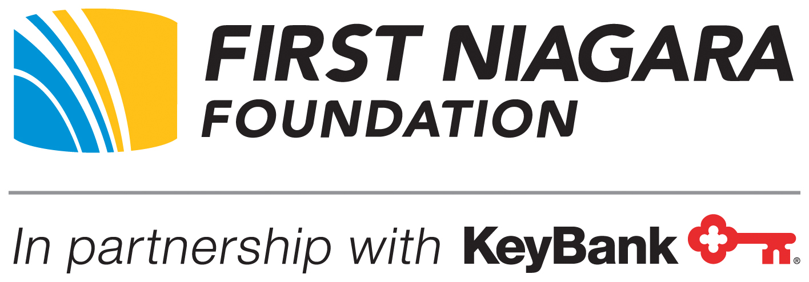

**FOR IMMEDIATE RELEASE**

**The Ralph C. Wilson, Jr. Foundation and First Niagara Foundation Partner**

**to Strengthen and Grow Mentoring across Western New York**

*$2.4 million grant to support collaborative of nine mentoring programs in the region*

**Buffalo, N.Y. (Aug. 23, 2017)** – The Ralph C. Wilson, Jr. Foundation and the First Niagara Foundation, in partnership with KeyBank, today announced a $2.4 million grant to support the Western New York (WNY) Mentoring Collective, a cohort of nine mentoring programs throughout the region.

The WNY Mentoring Collective is an ambitious effort to expand and strengthen the field of mentorship programs across the region, ultimately connecting more children with mentors. The organizations collaborating in this initiative include: ***Big Brothers Big Sisters of Erie County, Buffalo Prep, Classroom Champions, Chautauqua Striders, Compeer, Edge Foundation, Hillside Work-Scholarship, Say Yes Buffalo, and Youth Mentoring Services of Niagara County***.

This large-scale investment in mentorship will utilize the expertise of MENTOR: The National Mentoring Partnership and its statewide affiliate Mentor NY to help create a learning community among these proven local mentoring programs. The collective will benefit together from shared best practices, capacity building, mentor training, education and assessment support over the next two years.

“There’s tremendous value for children to have a caring adult role model, beyond their parents or guardians, to support, guide and empower them on their journey into adulthood,” said David Egner, President & CEO, Ralph C. Wilson, Jr. Foundation. “We applaud the cohort organizations for their commitment to work together and help close the mentoring gap in Western New York.”

“The funding from this grant will contribute to improved quality of programs in the region, while also helping to increase the number of mentors working with young people,” said Elizabeth Gurney, Executive Director, First Niagara Foundation. “We hope this investment will also serve as an invitation to professionals across all sectors in Western New York to get involved in the mentorship movement, serving as mentors and advising our youth on the path to success.”

Community Connections of NY (CCNY), a nonprofit management services organization, is overseeing the $2.4 million grant on behalf of the WNY Mentoring Collective. CCNY will be responsible for convening and connecting the nine organizations to MENTOR and Mentor NY throughout the process and Equal Measure of Philadelphia, PA will lead the evaluation and continuous quality improvement process for the collective.

###

**About the Ralph C. Wilson, Jr. Foundation**

*The Ralph C. Wilson, Jr. Foundation is a grantmaking organization dedicated primarily to sustained investment in the quality of life of the people of Southeast Michigan and Western New York. The two areas reflect Ralph C. Wilson, Jr.’s devotion to his hometown of Detroit and greater Buffalo, home of his Buffalo Bills franchise. Prior to his passing in 2014, Mr. Wilson requested that a significant share of his estate be used to continue a life-long generosity of spirit by funding the Foundation that bears his name. The Foundation has a grantmaking capacity of $1.2 billion over a 20-year period, which expires January 8, 2035. This structure is consistent with Mr. Wilson’s desire for the Foundation’s impact to be immediate, substantial, measurable and overseen by those who knew him best. For more information visit* [*www.rcwjrf.org*](http://www.rcwjrf.org)*.*

**About The First Niagara Foundation**

*Founded in 1998, the First Niagara Foundation will carry out the philanthropic legacy of First Niagara Bank and its predecessor Lockport Savings Bank by supporting not-for-profit organizations dedicated to empowering individuals and neighborhoods primarily in Western New York. The Foundation also continues a focus on supporting select quality youth mentoring in legacy markets previously served by First Niagara Bank.*

**Media Contacts:**

Christine Denham

Martin Davison Public Relations

281-433-5067

[cdenham@martingroupmarketing.com](mailto:kkolozsvary@martingroupmarketing.com)

Carly Strachan

Ralph C. Wilson, Jr. Foundation

313-460-8100

[carly.strachan@rcwjrf.org](mailto:carly.strachan@rcwjrf.org)